Case Study

Sweetened Beverage Taxes:
Lessons from a Decade

of Progress

Advocating for Ghana’s Health (A4H) Coalition.

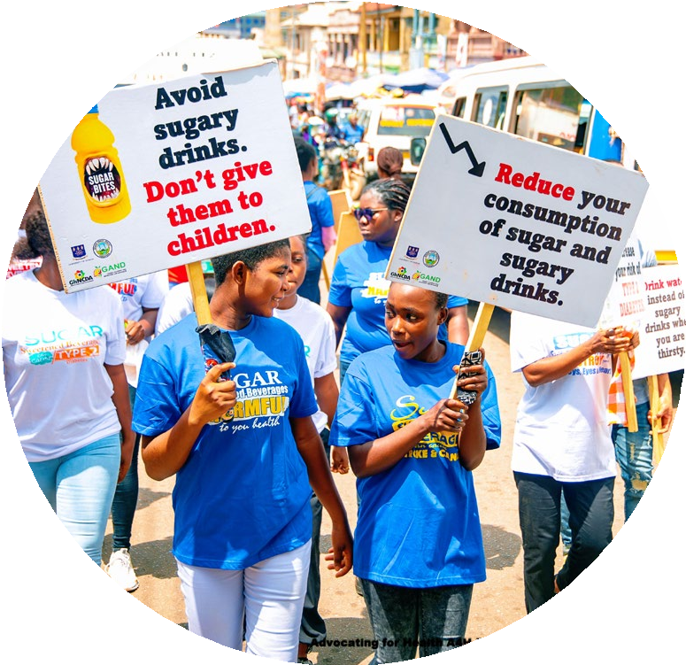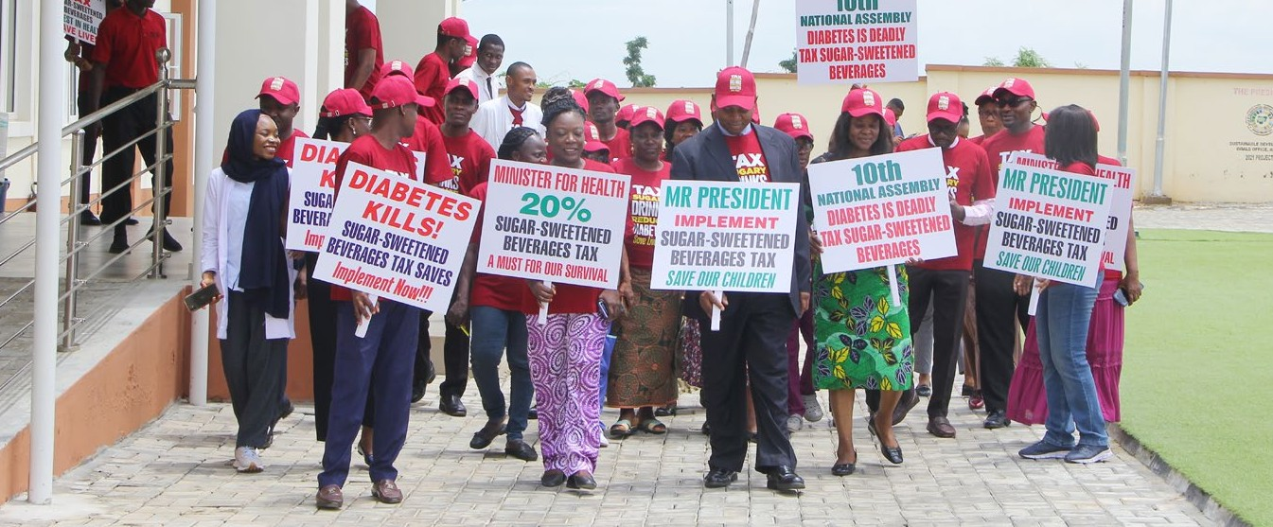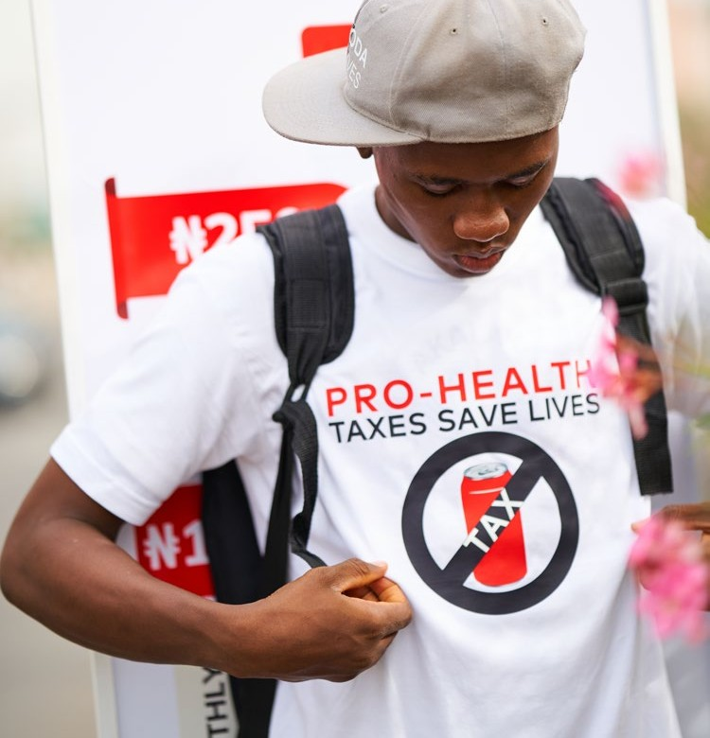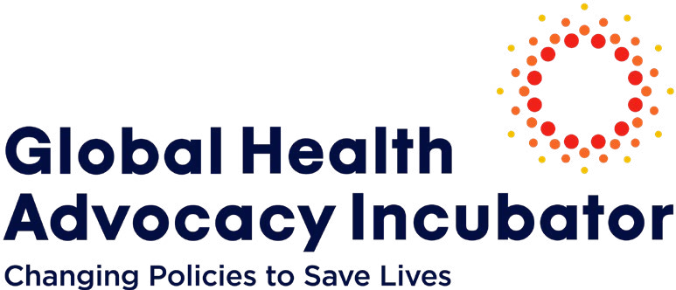Locally-led advocacy campaigns supported by
the Global Health Advocacy Incubator (GHAI) have contributed to the adoption and strengthening
of sweetened beverage (SB) taxes in Africa, the Caribbean, Latin America and South Asia. The lessons learned from these campaigns are being applied by advocates around the world to counter the threat caused by SBs in their countries and generate new government revenues.

The Case for Advocacy
for Sweetened Beverage Taxes
Excessive sugar consumption, including SBs with sugar and/ or non-sugar sweeteners, is a key contributor to a global health crisis of diet-related non-communicable diseases (NCDs) that claims approximately 184,000 lives annually. These drinks often displace healthier alternatives in the diets of children,
GHAI provides partners with intensive technical assistance and financial support for the passage of evidence-based sweetened beverage tax policies.

(left and above) Nigeria tax campaign.

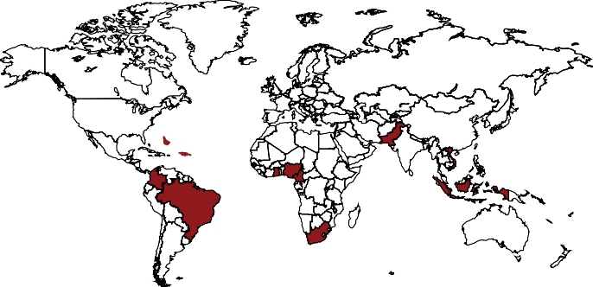A Global Movement

Where we work on sweetened beverage taxes:
Barbados, Brazil, Cameroon, Colombia, Ghana, Indonesia, Jamaica, Nigeria, St. Kitts and Nevis, South Africa, Pakistan
and Vietnam.

Our partners:
GHAI supports our partners to lead and sustain powerful advocacy movements in their own countries. Civil society partners working with GHAI to advance SB tax policy include ACT Brazil, Advocating for Ghana’s Health (A4H) Coalition, amandla.mobi, Colectivo de Abogados “José Alvear Restrepo (CAJAR), Center for Indonesia’s Strategic Development Initiatives (CISDI), Corporate Accountability for Public Participation Africa (CAPPA), DeJusticia, FIAN Colombia, Forum Warga Kota (FAKTA), Gatefield Impact, Georgetown University’s O’Neill Global Center for Legal Innovation on Food Environments, Healthbridge, Heart and Stroke Foundation of Barbados (HSFB), Healthy Caribbean Coalition (HCC), Healthy Living Alliance (HEALA),
Heart Foundation of Jamaica (HFJ), Javeriana University, Lake Health and Wellbeing, Pakistan National Heart Association (PANAH), Reconciliation and Development Association (RADA), Red PaPaz, Tal Cual, University of Ghana, University of North Carolina Chapel Hill’s Global Food Research Program, Vital Strategies and Yayasan Lembaga Konsumen Indonesia (YLKI).
low-income households and other vulnerable populations. These groups are the primary consumers of SBs and the burden of disease, along with its costs, falls disproportionately on them. In addition to driving NCDs and obesity, the consumption of mass produced sugary drinks comes with significant environmental costs.1,2,3,4 The production of SBs requires hundreds of gallons of water, placing an additional burden on already stressed
water resources5 , while the extensive use of plastic in beverage packaging contributes to environmental pollution.
Taxes on SBs have emerged as an important intervention for mitigating both the health and economic costs of these products.
Governments can use taxes to reduce the consumption of these beverages, improve public health and generatie revenues that can be used to strengthen sustainable health systems. Like other health excise taxes
that impact population-wide consumption habits, SB taxes can contribute to health and economic equity across an entire country. Because of how effective taxes are in driving down the consumption of SBs, the ultraprocessed food and beverage industry aggressively opposes them and as a result, evidence shows that intensive and strategic advocacy is critical to successfully implementing and protecting these
tax measures.

1 Garzillo JMF, Poli VFS, Leite FHM, Steele EM, Machado PP, Louzada MLDC, Levy RB, Monteiro CA. Ultra-pro- cessed food intake and diet carbon and water footprints: a national study in Brazil. Rev Saude Publica. 2022 Feb 28;56:6
2 Meisterling K et al. 2022. Healthy beverage initiatives: A case study of scenarios for optimizing their environmental benefits on a university campus, Cleaner and Responsible Consumption, 4:100049
3 Schmidt L, Mialon M, Kearns C, Crosbie E. “Transnational corporations, obesity and planetary health”
4 Gower R, Green J, Williams M. The burning question will companies reduce their plastic use?. 2020.
5 Cite: Schmidt, L., Mialon, M., Kearns, C., & Crosbie, E. (2020). Transnational corporations, obesity and planetary health. The Lancet Planetary Health, 4(7), e266-e267.




GHAI’s Role
The GHAI partners with civil society organizations around the world to develop and lead advocacy campaigns to pass policies promoting healthier food environments to protect health. GHAI provides partners with intensive technical assistance and financial support to the passage of evidence-based SB tax policies.
Guided by our belief that advocacy should be locally-led and implemented, GHAI provides capacity-strengthening support across domains including developing communications plans, reaching decision- makers, supporting legal action, building effective coalitions and countering industry
opposition. GHAI supplies technical tax design guidance to promote best practices, engages academic partners and our own research team to ensure that advocacy campaigns are evidence-informed and convenes national, regional and global communities of practice. To date, GHAI has supported 12 national tax advocacy campaigns.
GHAI and our partners have helped countries advance and defend SB taxation in diverse political and cultural contexts across multiple regions. Tax policy victories supported by GHAI include:
South Africa adopted a tax of approximately 10% (2.21 cents South Africa rand per gram of sugar over 4 grams per 100 ml) on sugar- sweetened beverages (SSBs). This tax, called
the Health Promotion Levy, was implemented in 2018 and contributed to a reduction in SSB purchases within a year.6 Our partners Healthy Living Alliance (HEALA) and amandla.mobi led advocacy efforts, mobilized grassroots support and leveraged the media to shape
a national conversation that overcame formidable industry opposition.

6 Wrottesley, S. V., Stacey, N., Mukoma, G., Hofman, K. J., & Norris, S. A. (2021). Assessing sugar-sweetened beverage intakes, added sugar intakes and BMI before and after the implementation of a sugar-sweetened beverage tax in South Africa. Public Health Nutrition, 24(10), 2900-2910.


Colombia advocates celebrate court decision in favor of SB tax. “News: The Constitutional Court Supports the Tax on Sugary Drinks.”

Barbados instituted a 10% tax on SSBs in 2015. Following advocacy led by the Heart and Stroke Foundation of Barbados, in March 2022 Prime Minister Mia Amor Mottley announced a tax increase to 20%.
Colombia adopted a pioneering tax in 2022 that included both SBs and “ultra-processed products” (UPPs), following an advocacy campaign by Colectivo de Abogados José Alvear Restrepo (CAJAR), DeJusticia, FIAN Colombia and Red PaPaz. The following year, in 2023, the Constitutional Court ruled that the tax is constitutional in response to a lawsuit by industry. The tax on SBs is sugar content-based and began implementation in 2023, with increases each year until 2025.
In Pakistan, advocacy by the Pakistan National Heart Association (PANAH) contributed to a groundbreaking SB tax in 2023 that takes a progressive approach, gradually raising the tax rate while expanding the range of products taxed (such as juices). The Federal Excise Duty includes a 20% tax on carbonated beverages, fruit juices, syrups and squashes containing added sugars and artificial sweeteners.
Nigeria adopted a 10 naira per liter SB tax in 2022 following advocacy by Gatefield Impact and the National Action for Sugar
Reduction (NASR) coalition along with diverse


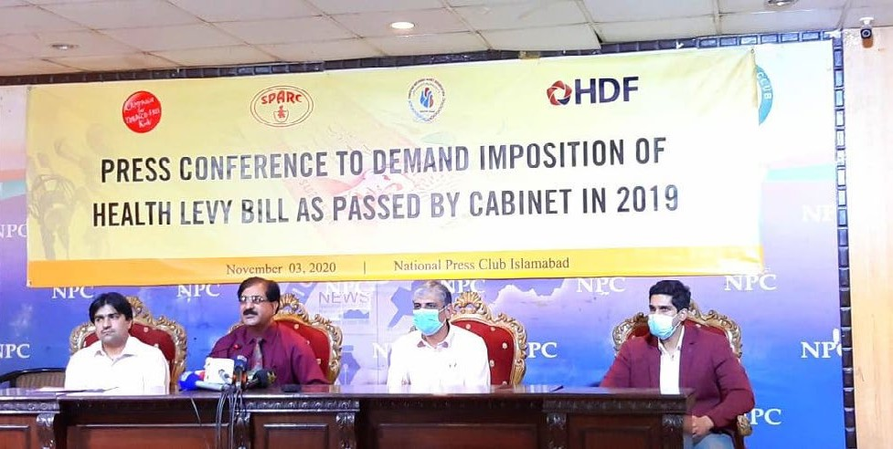
PANAH at a press conference in Pakistan.

stakeholders such as Corporate Accountability for Public Participation Africa (CAPPA).
Ghana adopted 20% taxes on many SBs including juices in 2023 following advocacy by the Advocating for Ghana’s Health Coalition, which included the University of Ghana School of Public Health, the Ghana NCD Alliance,
the Ghana Public Health Association and the Ghana Academy of Nutrition and Dietetics. This group of diverse stakeholders was united by a holistic commitment to public health and environmental sustainability.
While national contexts inevitably differ, several trends were consistent across countries and campaigns.

Designing Taxes to Achieve Public Health Objectives
Lessons learned from the implementation of SB taxes globally demonstrate that the approved taxes must be based on the highest standards and consistent with the principles of tax justice to achieve optimal public health outcomes.
Excise taxes are the most effective tax design to increase the prices of SBs and reduce their affordability to lower consumption. In addition, taxes must apply to all sweetened beverages shown to have negative health effects, including non-sugar sweeteners, to avoid substitution between unhealthy products.
The tax design should also reduce the affordability of harmful products and promote the consumption of healthy products.
Therefore, the tax rate must be high enough to create a price difference between taxable SBs and non-taxable, healthier beverages and increase the retail price succifiently to reduce consumer demand for SBs. In the long term, reduced consumption of SBs will improve public health.
Advocacy campaigns must call for the highest standard (most effective tax design) and continue to monitor the tax after policy passage. Advocates must also defend against industry pushes for weaker taxes, including fewer products in the definition of SBs or a lower tax rate, that could lessen their public health impact.

Reaching New Audiences
In Colombia, Ghana, Nigeria and Pakistan, successful advocacy for SB taxes employed diverse strategies to reach new
audiences. Colombia used a strategic media engagement approach at the regional and national levels, educating over 200 journalists about the implications of SB taxation and resulting in extensive media coverage. These efforts were leveraged through cross-sectoral advocacy strategies to reach key ministries such as the Ministries of Health, Finance, Agriculture, Housing and Trade. GHAI’s Colombia partners engaged small family farmers and other affected stakeholders
to speak out on the need for policy interventions to reduce the consumption of UPPs and reclaim traditional diets. At a time when the country faced high inflation and increased poverty and hunger, civil society effectively demonstrated the connections between UPPs, reduced access to real food and environmental damage.
Ghana’s A4H Coalition engaged a wide range of key actors across academia, civil society, the medical community and government bodies through diverse methods including position papers and virtual events. The coalition also sent members into communities with low literacy rates to build in-person support while simultaneously conducting a campaign across social and traditional media.

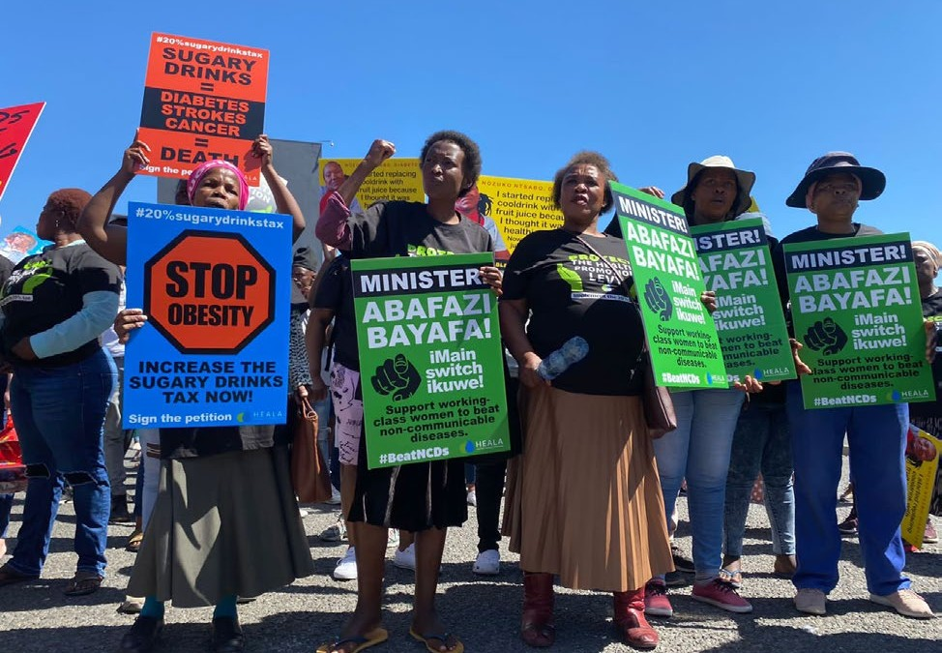
HEALA coalition members advocate for an SB tax increase in South Africa.

Nigeria combined earned and digital communications strategies, including in- person events and social media, to educate and mobilize diverse stakeholders. They broadened engagement by training health journalists and engaging social movements groups including environmental, gender justice and climate activists, underscoring the real environmental consequences of
SB production.
In advocating for SB taxes in Pakistan, PANAH strategically built a diverse coalition, engaging civil society organizations, health professionals and government officials through seminars and targeted meetings. Their comprehensive approach, including a digital media campaign, joint letters and outreach to religious
leaders and youth, trending hashtags like #TaxSugaryDrinksNotFuel on X, facilitated a unified call to action for SB taxes and a healthier future in the country.

Confronting Industry Interference and Legal Attacks
Advocacy campaigns worldwide have grappled with common industry interference tactics
and legal attacks that attempt to thwart SB taxes. In Pakistan and Nigeria, for example, opponents argued that the country would
face negative economic repercussions due to job losses. Coalitions such as PANAH and Gatefield Impact provided effective counter- narratives by dispelling myths surrounding economic downturns. Gatefield further emphasized the overburdended healthcare system and dire health consequences of unchecked SB consumption, especially in
light of the pandemic. In Nigeria, after the tax policy was passed, CAPPA deployed a group of young Nigerians as Digital Media Volunteers to combat industry misinformation in digital media spaces and build in-person awareness at the community level to sustain support
for the SB tax support in Nigeria despite strong opposition from industry and industry front groups.
In Ghana, the industry worked behind the scenes to coordinate over 70 petitions that were submitted to Parliament in opposition to the proposed legislation, a tactic that was ultimately unsuccessful due to the awareness health advocates had already raised among parliamentarians about widespread public support for the measure. The collective experiences of Pakistan, Nigeria and Ghana
highlight the importance of ongoing vigilance, including anticipating industry actions, employing strategic counter-narratives and adapting legal defenses to secure successful outcomes in the complex landscape of
SB advocacy.
In Colombia, the largest Colombian beverage company, Postobón, and the Coca-Cola Company pressed for a higher sugar threshold for products being taxed in the first phase
of the tax implementation. The Colombia SB tax is based on sugar content and it increases each year. By paying close attention to the tax design and industry attempts to weaken the tax, advocates protected public health
by convincing policymakers to adopt a lower sugar threshold than the industry had originally proposed, and as a result, the tax includes all harmful sugary drinks in the final phase of its implementation.
Following its approval, the Colombia SB tax immediately faced multiple legal challenges to

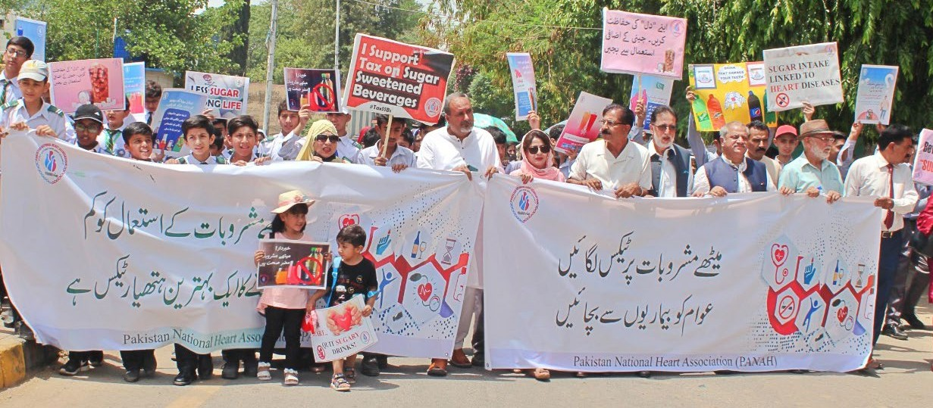
Advocates march in Pakistan.

its constitutionality. GHAI’s Colombia partners, including CAJAR, DeJusticia, FIAN Colombia and Red PaPaz, fought to protect the tax through a strategic legal defense process buttressed by ongoing communications efforts highlighting the tax’s public health benefits. Simultaneously, academic and civil society organizations throughout the region supported the efforts through amicus briefs
to the courts. GHAI submitted an amicus brief summarizing evidence and legal arguments supporting the measure. The Constitutional Court, a well-respected regional entity, ultimately sustained the constitutionality of the tax. The Court found that disincentivizing the consumption of sweetened beverages through taxes, considering their impact
on public health, in order to protect the right to health, was in accordance with the
constitution. This landmark decision protects and promotes public health in Colombia and provides a model for other nations facing similar threats.

Taxing Ultra-Processed Products
Colombia’s move to tax UPPs along with SBs sets a precedent for a comprehensive approach to health taxation with a public
health objective. Recognizing the detrimental health and environmental impacts of a
wide range of UPPs, including ready-to- eat meals, Colombia’s tax demonstrates a forward-thinking strategy that makes it the first country to tax unhealthy foods
based on nutritional content. This approach acknowledges the need to shift dietary patterns away from health-harming products with the goal of preventing obesity and NCDs. The success in Colombia emphasizes the potential of adopting a holistic taxation framework that targets a spectrum of unhealthy food and beverage products.

Implementation and Evidence Building
As countries celebrate policy victories, the advocacy focus shifts to sustained impact and continuous improvement. The experiences
of Colombia, Ghana, Pakistan and Nigeria underscore the need for ongoing evaluation and adaptation to ensure that the intended goals of these public health measures are achieved. This includes not only monitoring the implementation of taxes but also confirming that the taxes translate into higher prices
for SBs, thereby influencing consumer behavior. Moreover, rigorous monitoring of tax collection is imperative to prevent evasion and avoidance, safeguarding the integrity of the fiscal measures. It is crucial to measure the health impact of these policies in both
the short and long term to guarantee their sustainability and effectiveness in addressing public health challenges. This comprehensive monitoring and evaluation approach aligns with GHAI’s commitment to transparent governance and highlights the importance of robust data in fine-tuning existing policies and shaping future advancements in public health.

Lessons Learned
By navigating legal challenges, countering industry interference and building robust public support, countries can use evidence- informed advocacy to pave the way for transformative health policies. Key lessons learned include:
- Use Strong Narratives: It is imperative to emphasize the connection between the consumption of UPPs and poverty, decreased access to real food and environmental damage. This narrative serves to counter industry arguments that taxes are regressive for the poor and generate economic damage and job losses. Colombia advocates’ description of the economic damage imposed by UPP consumption on the health system as well as society more broadly proved compelling to policymakers.
- Build Tax Design Capacity: Given the critical need for an effective tax design, civil society organizations must be equipped to monitor the tax design and contribute to policy discussions. For this reason, there is a need to provide advocates with capacity strengthening opportunities, including building an
understanding of the papers that outline best practices and connecting with local health economists and tax experts.
- Engage Diverse Coalitions: Successful advocacy hinges on forming diverse coalitions. The tax campaigns discussed above overcame opposition by bringing together academia, civil society organizations, health professionals, social justice movements and government bodies. It was crucial to have local technical experts on the ground to combat industry attempts to derail the taxes. In Colombia, partners engaged academics who were free of conflicts of interest. These academics participated
in media interviews and public forums, sharing local and global evidence to support the tax proposals.
- Maintaining a Steady Media Drumbeat: Harnessing the influence of traditional and social media is crucial. Colombia’s #TaxSugarDrinksNotFuel hashtag, Ghana’s media mobilization strategy and Nigeria’s digital advocacy demonstrate the impact of strategic media engagement. Advocates should be prepared to carry out continuous industry monitoring to counter arguments effectively.
- Employ Tax Justice Principles: Tailoring messages to resonate with diverse communities is essential. Barbados advocates’ emphasis on health equity and addressing health disparities through SB taxation serves as a model for inclusive messaging. Consideration should be given to justifying the tax beyond revenue generation, using arguments related to health, environmental protection and human rights.
- Generate Research to Support Advocacy: Generating and leveraging local evidence strengthens advocacy efforts. Ghana’s focus on academic outputs, research dissemination and advocacy actions demonstrates the importance of using easily digestable evidence summaries in policyadvocacy. A similar engagement between researchers and policymakers in Barbados was
also helpful in strengthening calls for increasing the tax threshold. In Nigeria, advocates shaped the conversation
on how to implement an effective SB tax through a polycentric system of disseminating their simulation study.
- Empower Community Champions: Involving key opinion leaders such as Queen Mothers, nurses, professors, religious and traditional leaders amplify advocacy efforts. Ghana’s use of these opinion leaders, Pakistan’s identification of champions in parliament and Pakistan and Nigeria’s work with religious leaders showcase the role of influential figures in driving change.

Case Study

  - Prepare for Industry Opposition: Proactively addressing industry opposition is critical. Colombia’s response to oppositional arguments, Ghana’s and Pakistan’s handling of economic concerns and Nigeria’s advocacy in the face of industry interference highlight the importance of navigating challenges posed by industry stakeholders.
  - Build Public Support: Mobilizing public opinion through consumer surveys, public opinion polls and public awareness campaigns is a strategic advocacy tool. Pakistan’s effective utilization of this approach is exemplified by the National Opinion Poll conducted in early 2021. Nearly 78% of Pakistani adults expressed their endorsement for increasing taxes on SBs as a measure to address the rising concerns of obesity and NCDs. Advocates disseminated the results through various channels including media, briefs and targeted WhatsApp messages to parliamentarians. Nigeria conducted a similar nationally representative poll, and Ghana’s media mobilization approach used public opinion to drive policy change.
  - Be Flexible: Flexibility and adaptability are crucial for responding to changing contexts and opposition. Ghana advocates adjusted their strategy to address opposition arguments when the industry presented anti-tax petitions during parliamentary bill readings.
  - Collaborate with Government Allies: Collaborating across multiple government bodies and key policymakers is vital for policy adoption and successful implementation. Collaboration in Pakistan between the Ministry of Health, Federal Tax Ombudsman and Ministry of Finance laid
the groundwork for the eventual policy victory. Collaboration in Nigeria between the Ministry of Finance and Ministry of Health and engagement by health officials with the Parliament in Ghana all facilitated the adoption of their respective policies.
  - Monitor Implementation: Sustaining momentum after the passage of the tax is crucial, as policies may require ongoing defense from industry and annual adjustments based on increased living costs and inflation. To ensure long-term effectiveness, advocates must maintain vigilant monitoring and budget accountability measures, verifying that revenue is collected, the tax is implemented as intended and funds are allocated appropriately to maximize the intended health impact.
12. Monitor Implementation
11. Collaborate with Gov. Allies
10. Be Flexible
9. Build Public Support
8. Prepare for Industry Opposition
7. Empower Community Champions
6. Research to Support Advocacy
5. Employ Tax Justice Principles
4. Maintain Steady Media Drumbeat
3. Engage Diverse Coalitions
2. Build Tax Design Capacity
1. Use Strong Narratives
12 Lessons Learned for Budget Advocacy:

Global Health Advocacy Incubator

1400 I St. NW, Suite 1200,
Washington, DC 20005 USA info@advocacyincubator.org
advocacyincubator.org
@IncubatorGHAI
The Global Health Advocacy Incubator (GHAI) supports civil society organizations who
advocate for public health policies that reduce death and disease.

GHAI Case Study / Funding for this program provided by Bloomberg Philanthropies 8

